Devops Training

Mar -18

Tasks:

>>Install the jmeter

>> Create a Thread Group

>> Run the Sampler

Install the Jmeter

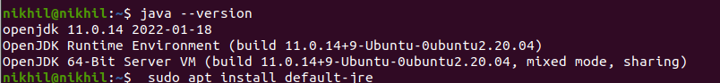

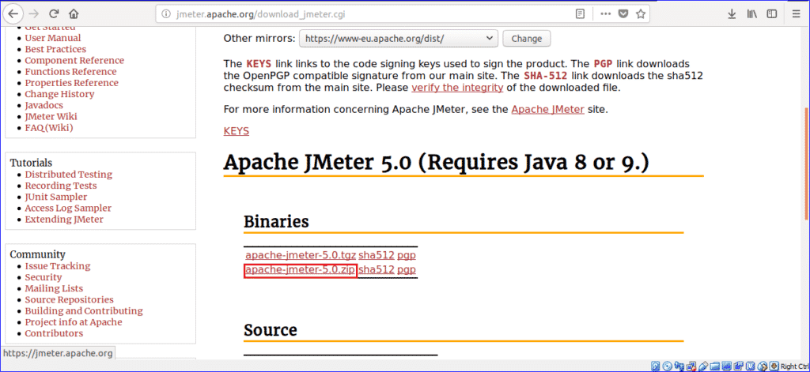

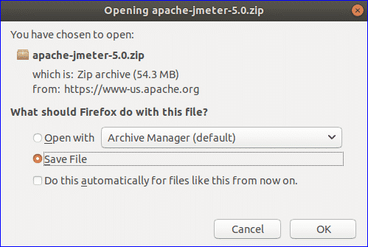

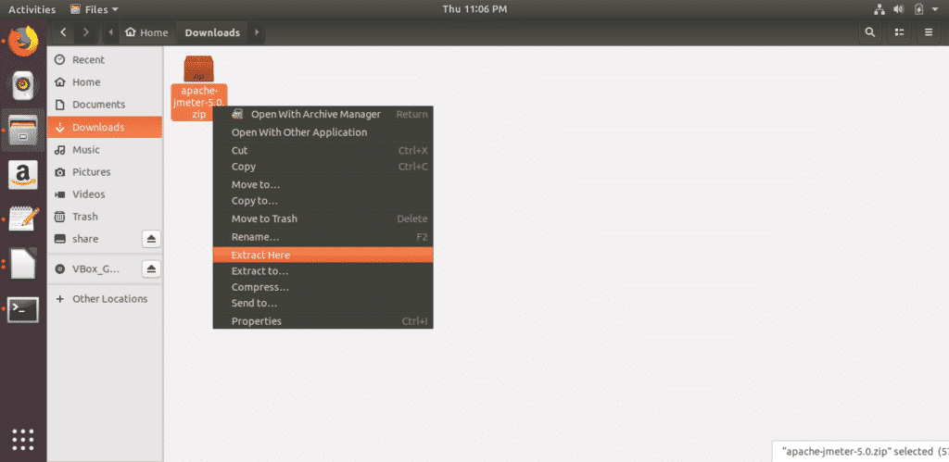

## **Run JMeter**

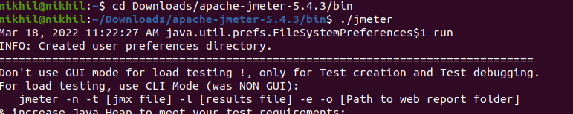



2) Create a Thread Group

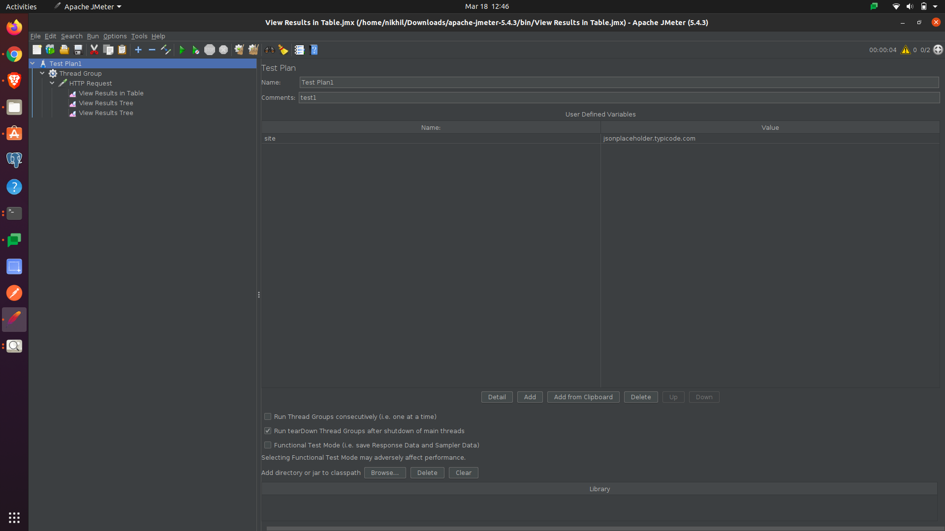

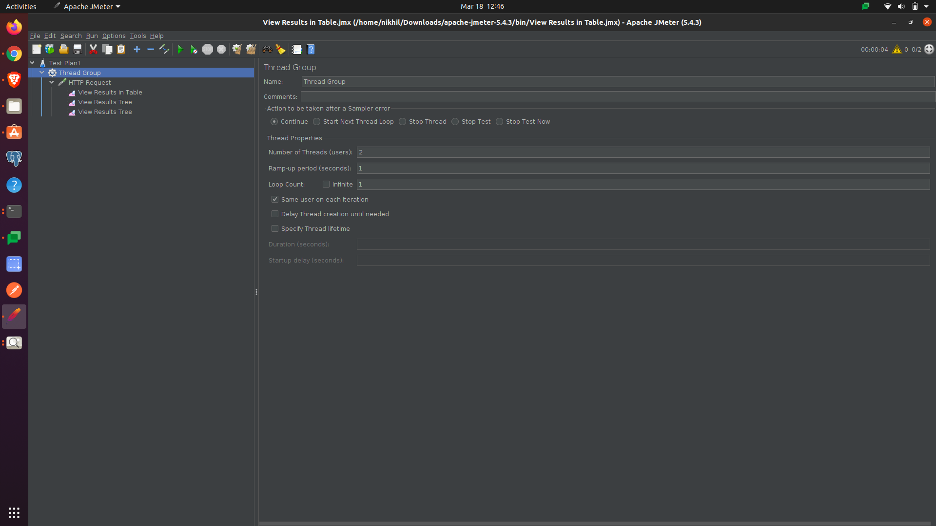

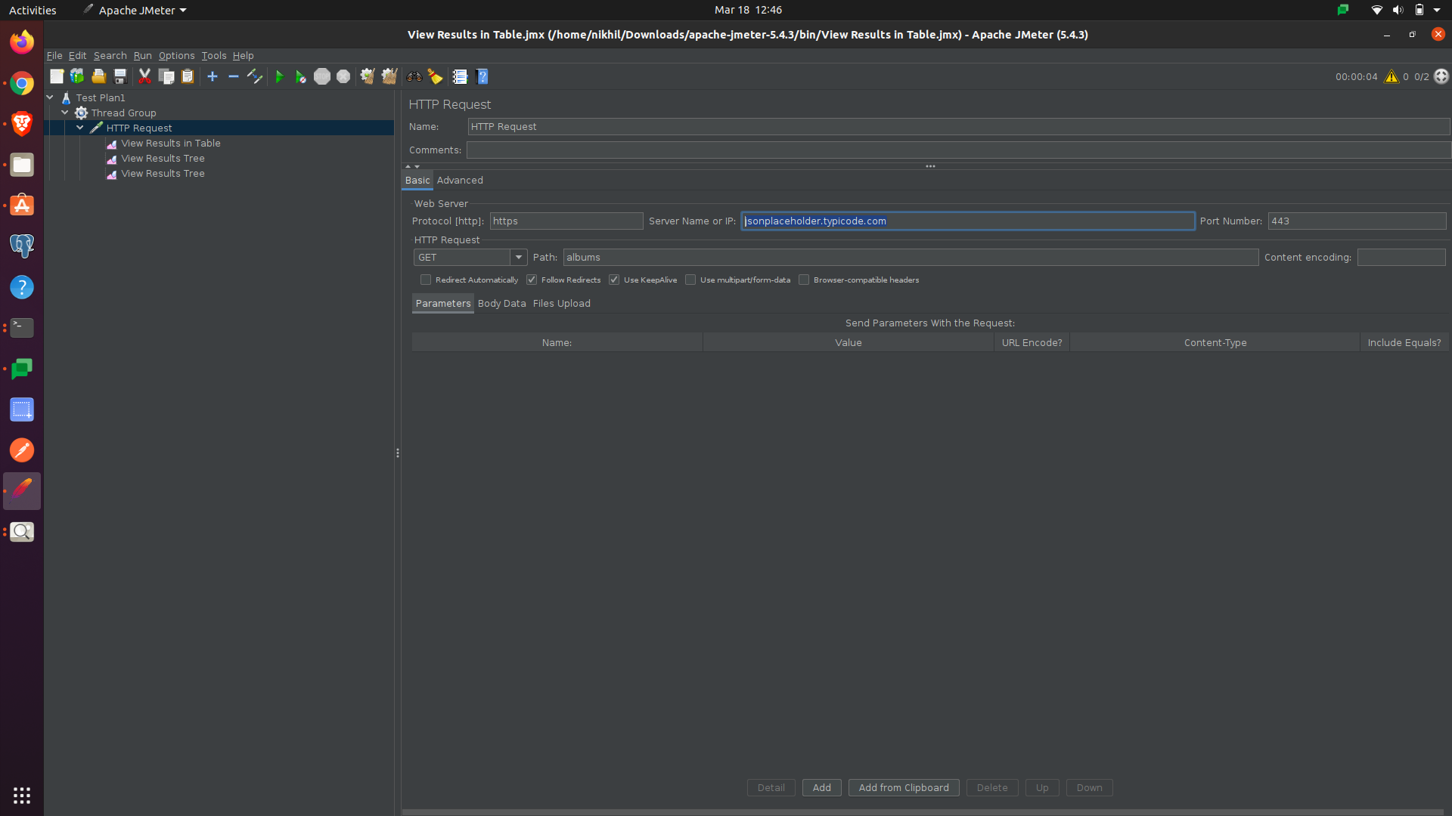

[Albums](https://jsonplaceholder.typicode.com/albums) Get Method

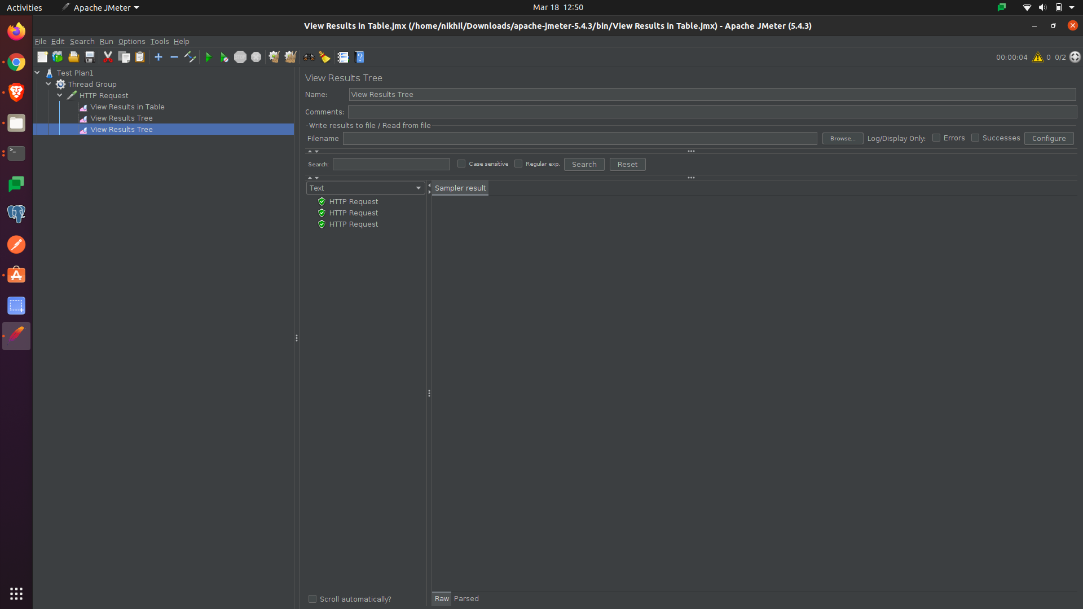

Todos Get method

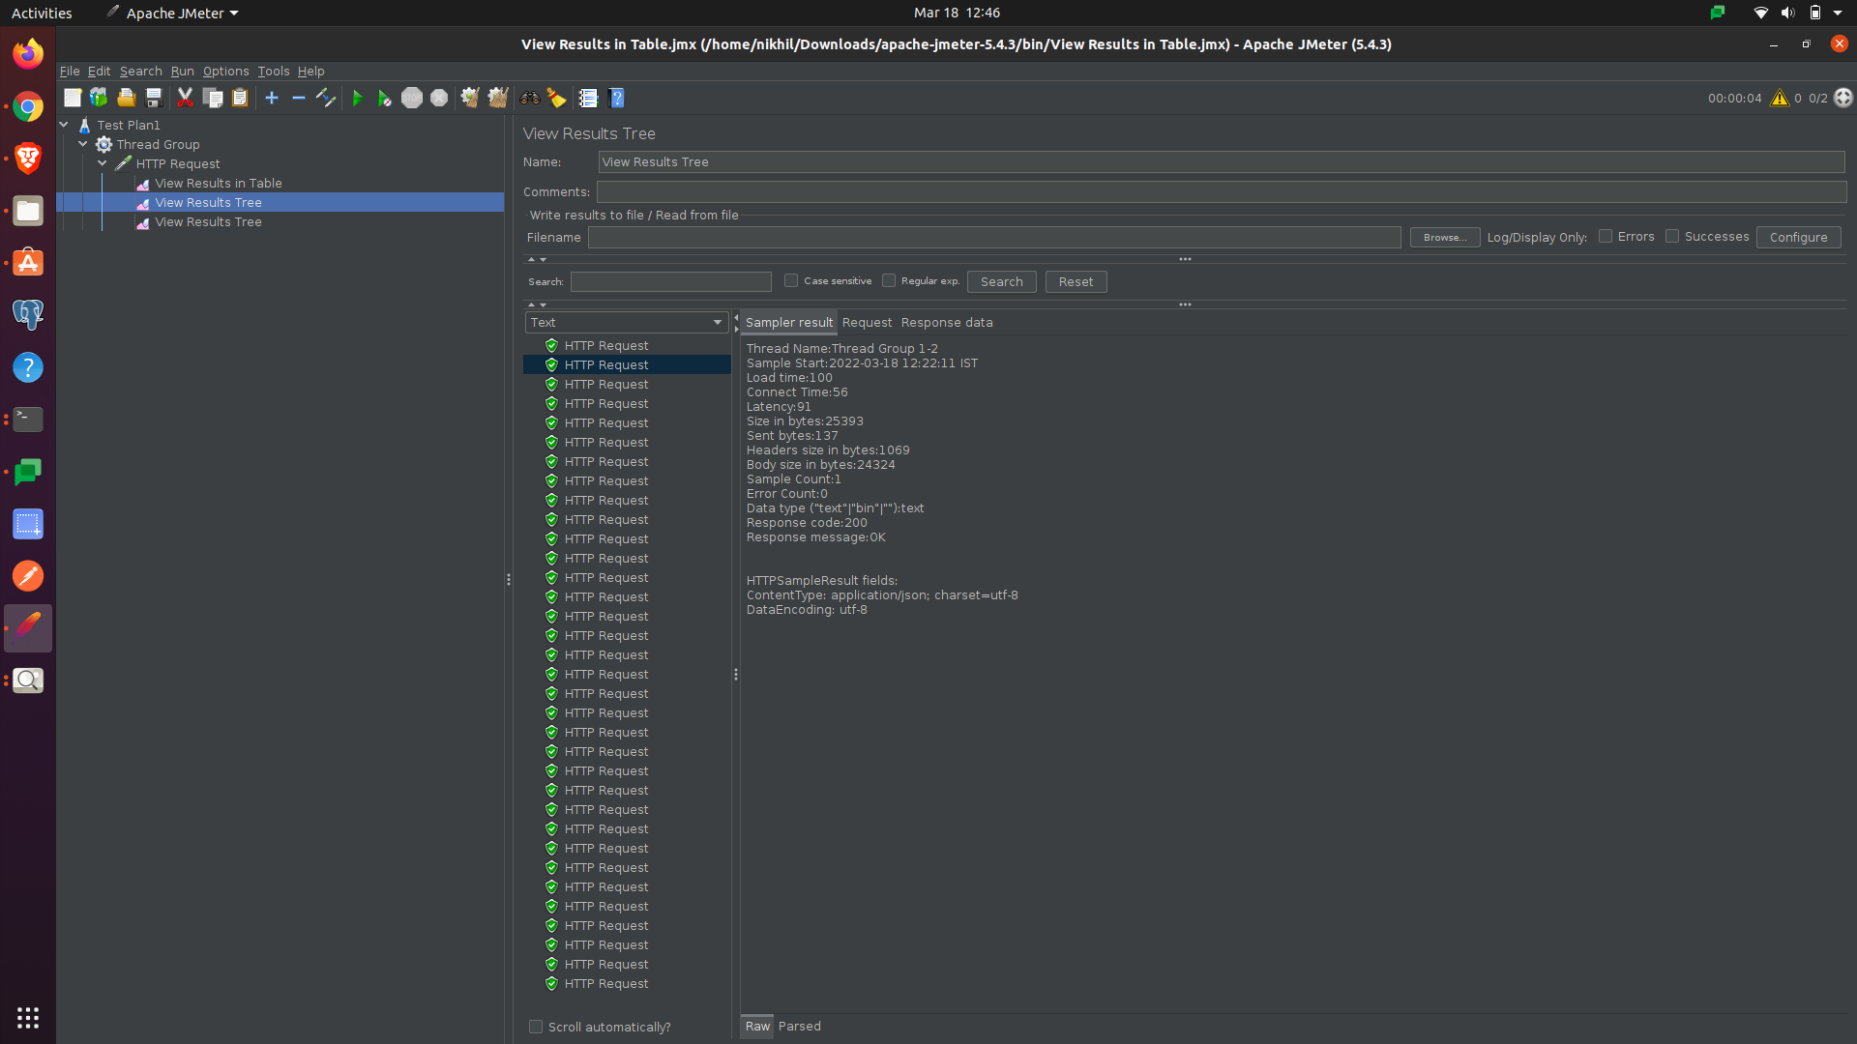

References :

<https://linuxhint.com/install_apache_jmeter_ubuntu/>

<https://www.how2shout.com/linux/install-apache-jmeter-on-ubuntu-20-04-lts-focal-fossa/>

<https://linoxide.com/install-apache-jmeter-on-ubuntu/>

[How to install Apache Jmeter on Ubuntu 18.04](https://www.youtube.com/watch?v=A_PSfvnIlz8)